Riga Technical University

FACULTY OF COMPUTER SCIENCE AND INFORMATION TECHNOLOGY

Fundamentals of Computer Graphics and Image Processing

Practical Work 1
TASK 1. STRAIGHT LINE ALGORITHEM
AND ADDITIONAL TASK

FCSIT
International Student
ZAID AHMAD SIDDIQUI
Stud. ID Nr.191ADB044

1.Task of Work
- During class you will be given the first half of the Bresenham algorithm that can draw straight horizontal lines (where dx>dy), complete this algorithm so that it could draw straight vertical lines (where dy>dx). The coordinates of the first and last point of the line are defined using 4 text fields.
- Upload the protocol of the task to Ortus (in *.pdf, *.doc or *.docx formats)

Programming Code

Graphics g = jPanel1.getGraphics();
g.setColor(Color.BLACK);
g.drawLine(0,0,jPanel1.getWidth(),jPanel1.getHeight());
g.drawLine(0,jPanel1.getHeight(),jPanel1.getWidth() , 0);
// int x1= jPanel1.getWidth()/2;
// int y1= jPanel1.getHeight()/2;
int x1=Integer.parseInt(jTextField1.getText());
int y1=Integer.parseInt(jTextField2.getText());
int x2=Integer.parseInt(jTextField3.getText());
int y2=Integer.parseInt(jTextField4.getText());

int dx = Math.abs(x2-x1);
int dy = Math.abs(y2-y1);
int xi,yi;
if(x1 < x2){ xi = 1;} else { xi = -1; }
if (y1<y2) { yi = 1;} else { yi = -1;}
if (dx > dy) {
int pn = 2*dy - dx;
int xn =295+ x1; int yn =250+ y1;//added 295 in x to make the starting from center,added 250in y1 to make the starting point
while ( xn != x2 ) {
if ( pn >0 ){
pn = pn +2*dy -2*dx;
xn = xn + xi;
yn = yn + yi;
}else {
pn = pn+2*dy;
xn = xn + xi;
}
g.drawRect(xn, yn, 1, 1);
}
}else if (dy>dx){
int pn = 2*dy - dx;
int xn = 295+x1; int yn = 250+y1;//added 295 in x to make the starting from center,added 250 in y1 to make the starting point
while ( xn != x2 ) {
if ( pn >0 ){
pn = pn +2*dx -2*dy;
xn = xn + xi;
yn = yn + yi;
}else {
pn = pn+2*dx;
yn = yn + yi;
}
g.drawRect(xn, yn, 1, 1);
}

}
}

Screen Shots
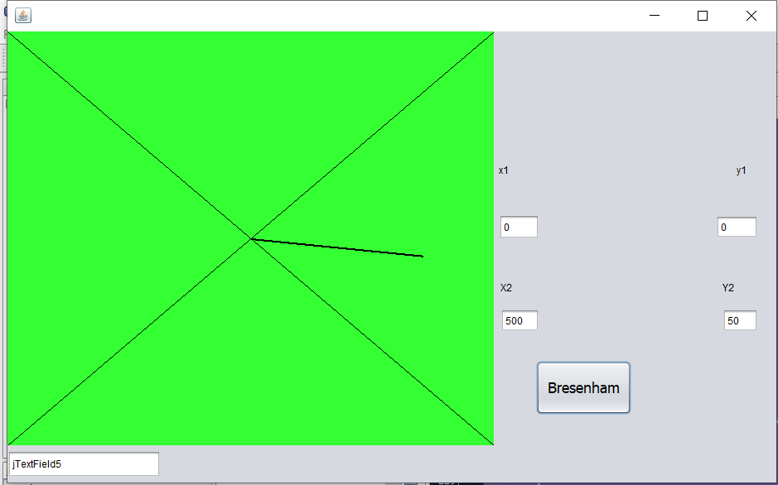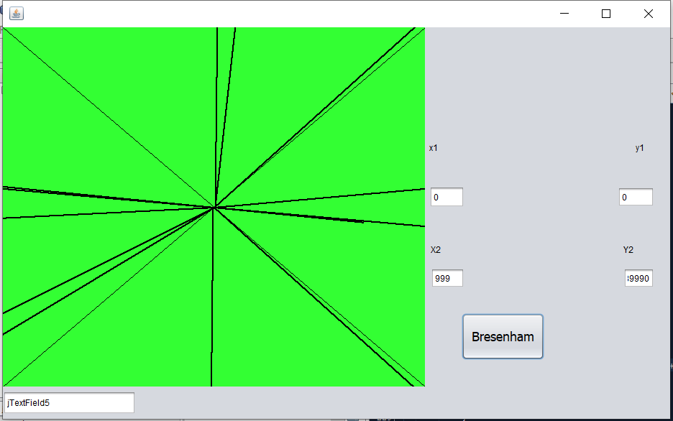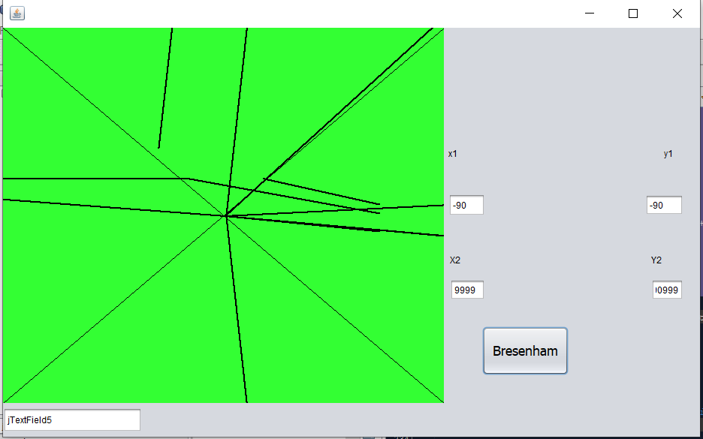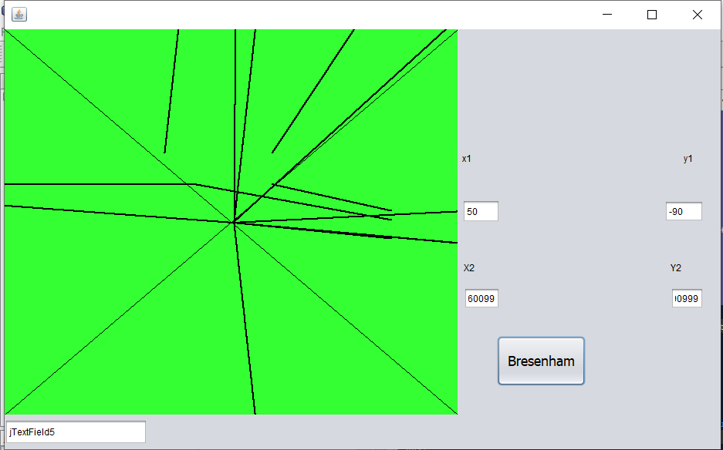

ADDITIONAL TASK

Task of Work
- Make it possible to define the coordinates of the first and last point of the line, by clicking on the image and using the mouse cursor position.
- Upload all program files to Ortus in an archive (in *.arj, *.zip or *.7z formats)
- Programming Code
package pack1;
import java.awt.Color;
import java.awt.Graphics;

public class NewJFrame extends javax.swing.JFrame {
int flag=0
public NewJFrame() {
initComponents();
}
private void jButton1ActionPerformed(java.awt.event.ActionEvent evt) {
Graphics g = jPanel1.getGraphics();
g.setColor(Color.BLACK);
g.drawLine(0,0,jPanel1.getWidth(),jPanel1.getHeight());
g.drawLine(0,jPanel1.getHeight(),jPanel1.getWidth() , 0);
int x1=Integer.parseInt(jTextField1.getText());
int y1=Integer.parseInt(jTextField2.getText());
int x2=Integer.parseInt(jTextField3.getText());
int y2=Integer.parseInt(jTextField4.getText());
int dx = Math.abs(x2-x1);
int dy = Math.abs(y2-y1);
int xi,yi;
if(x1 < x2){ xi = 1;} else { xi = -1; }
if (y1<y2) { yi = 1;} else { yi = -1;}
if (dx > dy) {
int pn = 2*dy - dx;
int xn =x1; int yn =y1;
while ( xn != x2 ) {
if ( pn >0 ){
pn = pn +2*dy -2*dx;
xn = xn + xi;
yn = yn + yi;
}else {
pn = pn+2*dy;
xn = xn + xi;
}
g.drawRect(xn, yn, 1, 1);
}
}else if (dy>dx) {
int pn = 2*dy - dx;
int xn = x1; int yn =y1;
while ( xn != x2 ) {
if ( pn >0 ){
pn = pn +2*dx -2*dy;
xn = xn + xi;
yn = yn + yi;
}else {
pn = pn+2*dx;
yn = yn + yi;
}
g.drawRect(xn, yn, 1, 1);
}
}
}

private void jPanel1MouseClicked(java.awt.event.MouseEvent evt) {
int x1,y1,x2,y2;
if (flag==0){
x1 = evt.getX();
y1 = evt.getY();
jTextField1.setText(Integer.toString(x1));
jTextField2.setText(Integer.toString(y1));
flag=1;
} else if(flag==1) {
x2 = evt.getX();
y2 = evt.getY();
jTextField3.setText(Integer.toString(x2));
jTextField4.setText(Integer.toString(y2));
flag=0; }
}

Screen Shots
